1. **What is Edge Computing? Discuss the benefits of Edge Computing.**

Answer: Edge computing refers to the enabling technologies allowing computation to be performed at the edge of the network, on downstream data on behalf of cloud services and upstream data on behalf of IoT services. Here we define “edge” as any computing and network resources along the path between data sources and cloud data centers. For example, a smart phone is the edge between body things and cloud, a gateway in a smart home is the edge between home things and cloud, a micro data center and a cloudlet [14] is the edge between a mobile device and cloud.

**Benefits of Edge Computing:** Edge Computing have several benefits compared to traditional cloud-based computing

* Edge computing things not only are data consumers, but also play as data producers.
* At the edge, the things can not only request service and content from the cloud but also perform the computing tasks from the cloud.
* Edge can perform computing offloading, data storage, caching and processing, as well as distribute request and delivery service from cloud to user
* Edge provides the requirement efficiently in service such as reliability, security, and privacy protection.
* The energy consumption could also be reduced by 30%–40% by cloudlet offloading

2.**Why we need Edge Computing?** OR **Why Edge Computing is more efficient than Cloud Computing?**

**Answer:** 1) Push From Cloud Services:

* Putting all the computing tasks on the cloud has been proved to be an efficient way for data processing since the computing power on the cloud outclasses the capability of the things at the edge.
* If more data needs to be sent to the cloud for processing, the response time would be too long. In this case, the data needs to be processed at the edge for shorter response time, more efficient processing and smaller network pressure.

2) Pull From IoT:

* Almost all kinds of electrical devices will become part of IoT, and they will play the role of data producers as well as consumers, such as air quality sensors, LED bars, streetlights
* raw data produced by them will be enormous, making conventional cloud computing not efficient enough to handle all these data.
* This means most of the data produced by IoT will never be transmitted to the cloud, instead it will be consumed at the edge of the network.

3) Change From Data Consumer to Producer:

People are producing data nowadays from their mobile devices. The change from data consumer to data producer/consumer requires more function placement at the edge.

For example, it is very normal that people today take photos or do video recording then share the data through a cloud service such as YouTube, Facebook, Twitter, or Instagram. However, the image or video clip could be fairly large and it would occupy a lot of bandwidth for uploading. In this case, the video clip should be demised and adjusted to suitable resolution at the edge before uploading to cloud. Another example would be wearable health devices. Since the physical data collected by the things at the edge of the network is usually private, processing the data at the edge could protect user privacy better than uploading raw data to cloud.

**2. Differentiate between Cloud Computing and Edge Computing through diagram.**

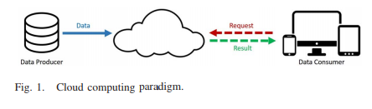

Fig. 1 shows the conventional cloud computing structure. Data producers generate raw data and transfer it to cloud, and data consumers send request for consuming data to cloud, as noted by the blue solid line. The red dotted line indicates the request for consuming data being sent from data consumers to cloud, and the result from cloud is represented by the green dotted line. However, this structure is not sufficient for IoT. First, data quantity at the edge is too large, which will lead to huge unnecessary bandwidth and computing resource usage. Second, the privacy protection requirement will pose an obstacle for cloud computing in IoT.

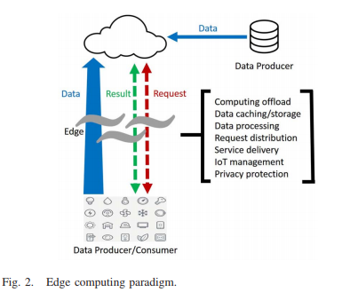

Fig. 2 illustrates the two-way computing streams in edge computing. In the edge computing paradigm, the things not only are data consumers, but also play as data producers. At the edge, the things can not only request service and content from the cloud but also perform the computing tasks from the cloud. Edge can perform computing offloading, data storage, caching and processing, as well as distribute request and delivery service from cloud to user.

**4.Discuss about Cloud Offloading where edge computing could shine to further illustrate our vision of edge computing?**

Answer:

Numbers of researches have addressed the cloud offloading in terms of energy-performance tradeoff in a mobile-cloud environment .In edge computing, the edge has certain computation resources, and this provides a chance to offload part of the workload from cloud.

In the traditional content delivery network, only the data is cached at the edge servers. This is based on the fact that the content provider provides the data on the Internet. In the IoT, the data is produced and consumed at the edge. Thus, in the edge computing not only data but also operations applied on the data should be cached at the edge.

Shopping with mobile devices is becoming more and more popular, it is important to improve the user experience, especially latency related. In such a scenario, if the shopping cart updating is offloaded from cloud servers to edge nodes, the latency will be dramatically reduced. As we mentioned, the users’ shopping cart data and related operations both can be cached at the edge node.

**5. How can improve the interactive services quality by reducing the latency?**

Answer:

By leveraging edge computing, the latency and consequently the user experience for time-sensitive application could be improved significantly. r. One simple solution is to cache the data to all edges the user may reach. Then the synchronization issue between edge nodes rises up. All these issues could become challenges for future investigation. At the bottom line, we can improve the interactive services quality by reducing the latency. Similar applications also include the following.

* Navigation applications can move the navigating or searching services to the edge for a local area, in which case only a few map blocks are involved.
* Content filtering/aggregating could be done at the edge nodes to reduce the data volume to be transferred.
* Real-time applications such as vision-aid entertainment games, augmented reality, and connected health, could make fast responses by using edge nodes.

**6. how Edge Computing illustrate our vision of edge computing in Smart City and Smart Home?**

**Answer: Smart Home:** IoT would benefit the home environment a lot. Some products have been developed and are available on the market such as smart light, smart TV, and robot vacuum. However, just adding a Wi-Fi module to the current electrical device and connecting it to the cloud is not enough for a smart home.

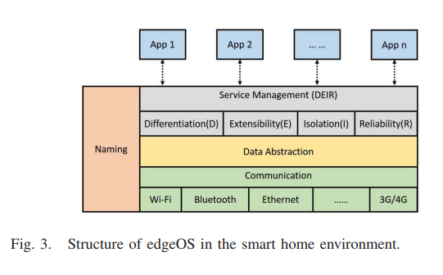

Fig.3 shows the structure of a variant of edgeOS in the smart home environment. EdgeOS needs to collect data from mobile devices and all kinds of things through multiple communication methods such as Wi-Fi, BlueTooth, ZigBee, or a cellular network.

**Smart City:** The edge computing paradigm can be flexibly expanded from a single home to community, or even city scale. Edge computing claims that computing should happen as close as possible to the data source. Edge computing could be an ideal platform for smart city considering the following characteristics.

* Large Data Quantity: A city populated by 1 million people will produce 180 PB data per day by 2019 , contributed by public safety, health, utility, and transports, etc. Building centralized cloud data centers to handle all of the data is unrealistic because the traffic workload would be too heavy. In this case, edge computing could be an efficient solution by processing the data at the edge of the network.
* Low Latency: For applications that require predictable and low latency such as health emergency or public safety, edge computing is also an appropriate since it could save the data transmission time
* Location Awareness: For geographic-based applications such as transportation and utility management, edge computing exceed cloud computing due to the location awareness

**7. What are the potential benefits of collaborative edge?**

**Answer:** To show the potential benefits of collaborative edge, we use connected healthcare as a case study.

A patient theoretically will follow the prescription to get the pills from a pharmacy. One possibility is that a patient did not follow the therapy. Then the hospital has to take the responsibility for hospitalization since it cannot get the proof that the patient did not take the pills. Now, via collaborative edge, the pharmacy can provide the purchasing record of a patient to the hospital, which significantly facilitates healthcare accountability.

At the same time, the pharmacies retrieve the population of the flu outbreak using the collaborative edge services provided by hospitals. An apparent benefit is that the pharmacies have enough inventory to obtain much more profits.

Behind the drug purchasing, the pharmacy can leverage data provided by pharmaceutical companies and retrieve the locations, prices and inventories of all drug warehouses. It also sends a transport price query request to the logistics companies. Then the pharmacy can make an order plan by solving the total cost optimization problem according to retrieved information.

The centers for disease control and prevention, as our government representative in our case, is monitoring the flu population increasing at wide range areas, can consequently raise a flu alert to the people in the involved areas. Besides, further actions can be taken to prevent the spread of flu outbreak. After the flu outbreak, the insurance companies have to pay the bill for the patients based on the policy. The insurance companies can analyze the proportion of people who has the flu during the outbreak.

Thus most of the participants can benefit from collaborative edge in terms of reducing operational cost and improving profitability.

.